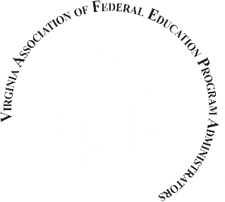

TO: Federal Coordinators
FROM: Jennifer Hurt, VAFEPA Scholarship Chairperson
SUBJECT: 2017 NAFEPA/VAFEPA Scholarship Program
Virginia Association of Federal Education Program Administrators (VAFEPA) proudly announces the opportunity for a national scholarship for Virginia students. National Association of Federal Education Program Administrators (NAFEPA) will be selecting three (3) $2,500.00 scholarships recipients. These scholarships are given to honor three (3) NAFEPA members who have shown and provided exemplary leadership and dedication to the Association and the students the organization represents. Eligibility is open to high school seniors who are presently enrolled in a public school or high school graduates who are attending their first year of college. NAFEPA offers three (3) different scholarships:
- Applicant is pursuing a degree in Education.
- Applicant is pursuing a degree other than Education.
- Applicant is pursuing any degree.
Based on the required criteria listed in the application attached, the VAFEPA Scholarship Committee will review the completed scholarship applications and select two (2) candidates to represent Virginia for the National Scholarship Program. The two state representatives will each receive $500.00. Final judging for the NAFEPA Scholarships of all states represented will occur at the national level. Virginia students have received this national award numerous times, including last year.
Please distribute the attached application form to eligible and interested persons in your school district. As indicated on the application, the amount of each scholarship will be made payable to the institution of choice, only after a letter is received from the institution verifying the student is enrolled.
The completed application must be returned by mail or electronically submitted to:
Jennifer Hurt, VAFEPA Scholarship Committee Chairperson, Bristol City Public Schools 220 Lee Street, Bristol, VA 24201-4198,
Or email to: jhurt@bvps.org
DEADLINE: February 7, 2017
If you have any questions regarding this process, please contact Jennifer Hurt at (276) 821-5646.
Attachments:
- NAFEPA Scholarship Program Outline and Process
- NAFEPA Scholarship Application Form

